# UDEMY SUBSCRIBERS’ ANALYSIS ROPORT

PROJECT BACKGROUND

Udemy is an educational technology company, i.e : it offers digital courses and educational resources to its subscribers. The purpose of this analysis is to explore the data on courses from different topics to understand where opportunities to increase revenue may lie, and track the performance of courses.

This report aims to explore the database and make logical recommendations on how to increase the company’s next quarterly earnings.

# PROJECT DESIGN

Data was consolidated by joining the databases of the four subjects that Udemy offers to its subscribers: Web Development, Graphic Design, Business Finance, and Musical Instruments on one spread sheet.

Data cleaning was done by deleting blank spaces, rows that had distorted information and repeated rows via functions available in the google spreadsheet environment. This was done to have good representation of data and to avoid repetition in the overall results.

Data manipulation was carried out on this data sets to show the number of non-paying subscribers that enjoy the free courses on Udemy as well as the top twenty courses subscribed to.

Data visualization via google spreadsheet and tableau; the charts generated via google spreadsheet shows the average measures of dispersion as regards cost of courses and ratings, this gave an overview of our customer’s (subscribers) behavior. However, analysis and visualization on Tableau uncovered more insights on the data with specific analytics on each subject.

# FINDINGS 1

Subscriptions on Udemy platform are optional, subscribers would normally choose subject they are interested in. As illustrated in Fig.1.1, Web development is the subject with the highest participation as it accounts for 67.9% of total subscribers on the Udemy platform. On the other hand, Musical Instruments is the subject with the lowest amount of participation at 7.2% of the total subscribers’ population.

The platform provides both free and paid courses; this can help newbies in a subject have an over view of what their subject of interest is about or even help them decide on which subject to focus on. As illustrated on Fig.2.1 the ratio of paid subscribers to free subscribers on the platforms is approximately 5:2 (Paid subscribers were recorded at 60.5% while free subscribers are recorded at 30.5%)

Each subject on Udemy have three (3) categories: Beginner Level, Intermediate Level and Expert Level. As illustrated in Fig.3.1, across all level of subjects, the beginner level of Web development has the highest number of subscribers with almost three (3) million subscribers while the expert level of Graphic design has the lowest number of subscribers with less than five hundred thousand (500,000) subscribers.

Figure 1.1

Figure 1.2

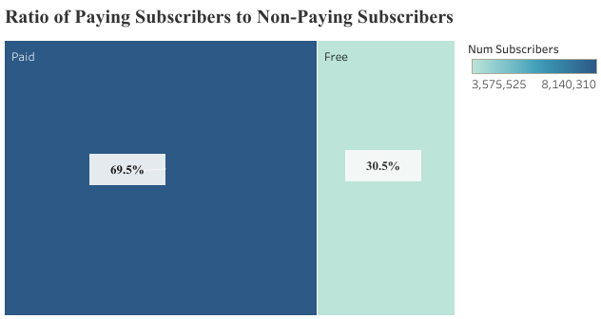

Figure 1.3

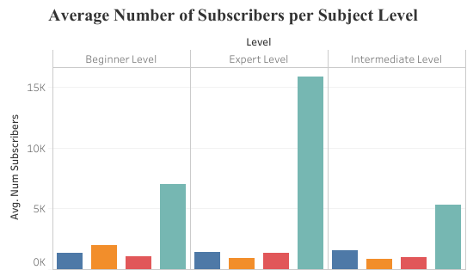

# FINDINGS 2

As there are different subject levels on Udemy, there are also varying prices of learning levels per subject. As illustrated in Fig 1.2, the Intermediate level of Web Development has the highest average price at almost 85 units, the second highest average cost is the beginner level of Web Development at 87 nits and the third highest average cost id the beginner level of Business Finance.

Content duration refers to the amount of video time it takes to finish a course in each subject level. This also varies by subject level just as the prices of the subjects vary. As illustrated in Fig2.2, the expert level of Musical Instrument has the average highest time to complete its course, followed by the beginner level of Web Development and we have the third highest content duration at the Beginner level of Business Finance.

Figure 2.1

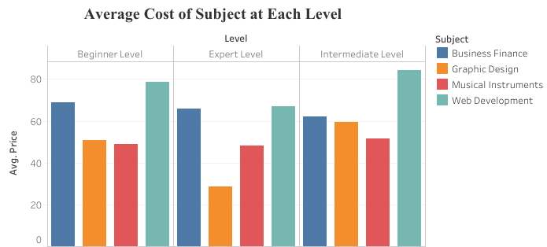

Figure 2.2

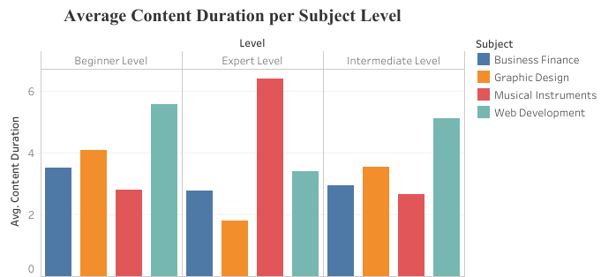

# FINDINGS 3

After the completion of any course under any subject on the learning platform, subscribers are asked to giving ratings bases on their satisfaction. These ratings reflect how well the courses helped their understanding of the subject, improved their skill sets and how the knowledge and skill sets aided their employability in the job market.

As illustrated in Fig.1.3, the subject level with the highest rating is Business Finance followed by Web Development while Musical Instruments is the subject with the lowest rating.

Further analysis in Fig.2.3 shows that the beginner level of all subjects are significantly higher than the subsequent levels, with the expert level having the lowest ratings across all four (4) subjects. The chart shows that the beginner level of Business Finance has the highest level of ratings followed by the beginner level of Web Development.

Figure 3.1

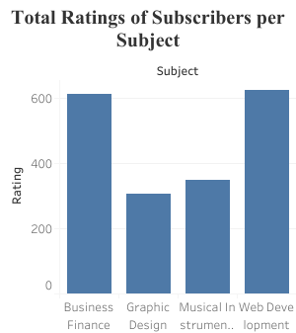

Figure 3.2

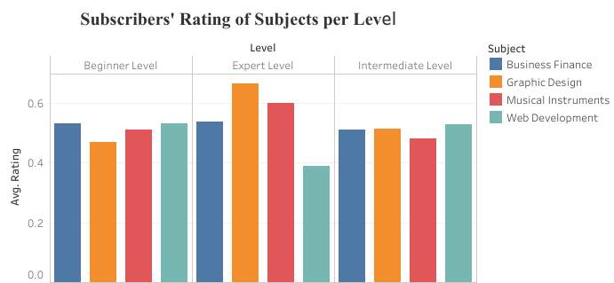

FINDINGS 4

Due to different prices of level per subject, the company’s earnings vary per subject and level of learning. As illustrated in Fig.1.4, Web Development and Business Finance are the highest contributors to Udemy’s income while Musical Instrument is the subject that contributes least to the company’s earnings.

Further analysis in Fig 2.4 shows that the the beginner levels of each subject generally generate more income than the subsequent levels. Beginner level of Web Development generate the highest income for Udemy while the lowest contributor to earnings at each subject level is the expert level of Graphic design.

Figure 4.1

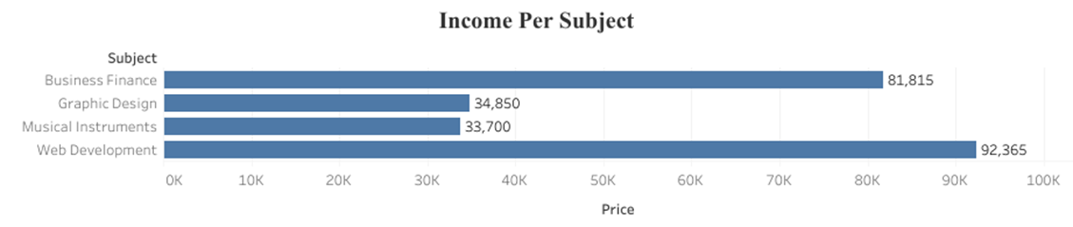

Figure 4.2

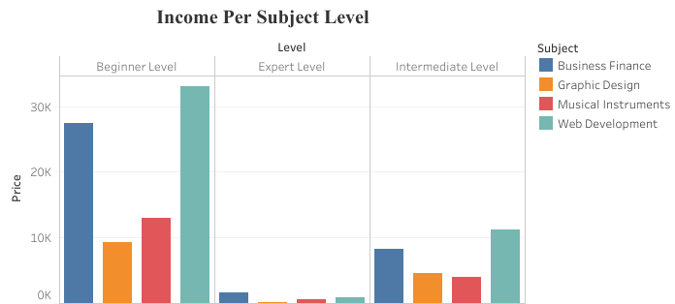

# ANALYSIS

Web Development and Business Finance are the top performing subjects on Udemy, Fig. 1.1 shows that 67.9% of our total subscribers are subscribed to Web Development while 17.9% of the total subscribers are subscribed to Business Finance. On the other hand, Musical Instruments is the least participated subject.

The beginner levels generally generate more income for the company. In Fig.3.1, it is evident that the beginner level of each course has more subscribers than the subsequent levels, however the beginner level of Web Development has the highest number of subscribers across all levels of subjects, as its number is at five (5) times higher than other levels of subjects.

The highest average cost of all the level of subject is the Intermediate level of Web Development followed by its beginner level, beginner level of Business Finance has the third highest average cost. Even with the cost consequence, Web development accounts for 39% of the total earnings while Business Finance accounts for 33% of the total earnings. This shows that Web Development is the subject with the highest demand on the platform, followed by Business Finance while Musical Instruments remains the least subject of interest on the platform as seen on previous charts.

One would think that the content duration of a course might discourage participation of subscribers but this is not the case in this analysis. As illustrated on Fig.2.2, beginner Web Development has the second highest average content duration and this does not stop it from being the most engaged subject on the platform. Safe to say it is the people’s favourite.

The reason for the high performance of Web Development on the earnings and ratings on Udemy could be that it is a skill that is currently in demand in the labour market. It could as well be that Udemy’s modules of Web Development are very satisfactory for customers and equips them with necessary employable skills.

Another Interesting insight is the difference of number of subscribers between the beginner levels and subsequent levels. This could be an indication of customer’s behavior based on either satisfaction gotten from taking the courses or the efficiency of the beginner levels. It could be that subscribers do not subscribe to the subsequent because they lost interest in the subject or maybe they prefer to take the subjects with Udemy’s competitors. It could also imply that the beginner level is comprehensive and functional enough for subscribers such that the skills learned at the beginners level is sufficient to land a job role in their field of interest and then, they subsequently learn on the job.

# CONCLUSION AND RECOMMENDATION

From the analysis and charts above, it is recommended to increase the price of the beginner levels of each subject, as the beginner level is the top performer of all subjects. Furthermore, the prices of beginner, intermediate and expert levels of Web Development and Business Finance is recommended as they are the two (2) most popular subjects on the platform. Hence, an increase in their prices would not make the company experience a significant reduction of subscribers.

Just as subscribers are asked to rate subjects they take on the platform, we can can request customers to fill survey forms that would help us gather data and insights as to why the numbers of participation in intermediate and expert level is generally low. The survey can also help us identify our competitors’ strengths and weakness, thereby allowing us to leverage on that by modifying the subjects’ content to give the subscribers and prospective subscribers the ultimate satisfaction.

In the light of retaining existing subscribers and securing prospective subscribers, we can offer remote internship opportunities to subscribers that finish with the expert level. In addition to this, we can offer birthday discount on courses to our existing subscribers.